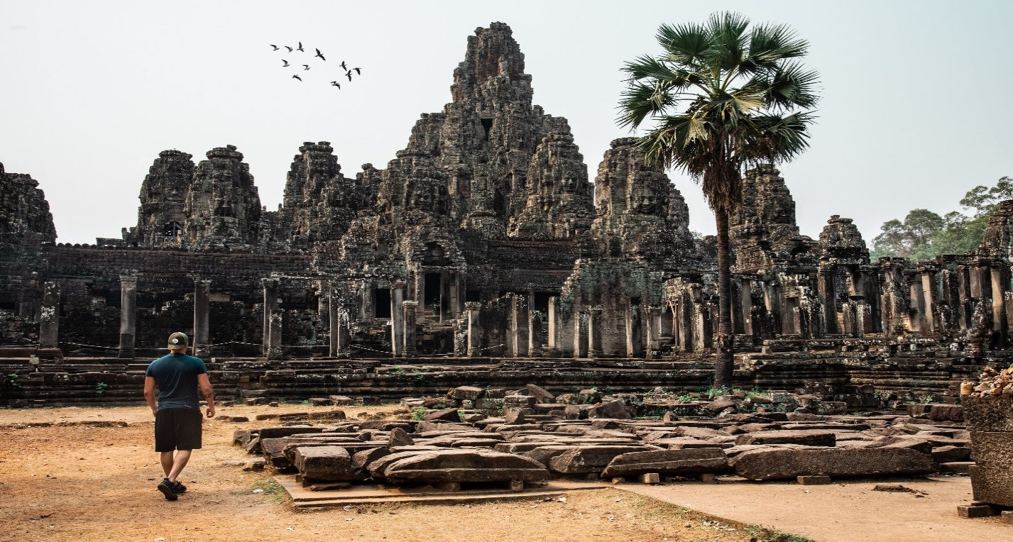

**Agkor Wat**

Angkor Wat is a UNESCO World Heritage site in Cambodia, renowned for its stunning Khmer architecture and being the largest religious monument globally.

**History**

Angkor Wat, built in the 12th century, is a UNESCO World Heritage site in Cambodia and the largest religious monument globally, showcasing the pinnacle of Khmer architecture and serving as a Hindu, then Buddhist, temple complex.